SOFTWARE TESTING
PRACTICAL REPORT
PR-15 | Selenium WebDriver Automation Testing

Particular | Details
Student Name | Parth Fegade
Enrollment Number | ____________________________
Course / Semester | BCA – Semester 3
Practical | PR-15
Application Under Test | SauceDemo (https://www.saucedemo.com/)
Tools Used | Python, Selenium WebDriver, Google Chrome, PyCharm

Submitted as part of the Software Testing practical work.

1. Practical Overview
This practical demonstrates automated authentication testing on the SauceDemo website using Python and Selenium WebDriver. The test suite covers successful login, rejection of invalid credentials, validation of empty credentials, assertions, error-message verification, exception handling, and logout. The screenshots supplied with the practical are included as execution evidence.

2. Aim
To create and execute automated login tests using Selenium WebDriver with Python, validate authentication behavior for valid and invalid inputs, use assertions and exception handling, and document the observed results with screenshots.

3. Problem Statement
Create an automated Selenium login-testing script that performs valid login, invalid-password testing, invalid-username testing, empty-credential testing, authentication assertions, error-message validation, exception handling, and logout.

4. Software and Requirements
Parameter | Details
Project Name | Automated Login Testing
Application / Software | SauceDemo
Module | Authentication / Login
SDLC Model | Agile
Programming Language | Python 3.x
IDE / Tool | PyCharm
Automation Tool | Selenium WebDriver
Browser | Google Chrome
WebDriver | Selenium-managed Chrome WebDriver
Target URL | https://www.saucedemo.com/
Input / Test Data | Valid and invalid login credentials

5. Test Coverage
Test Area | Expected Behavior / Verification
Browser launch | Chrome opens under Selenium control.
Website navigation | SauceDemo login page loads.
Valid authentication | Valid credentials open the inventory page.
Invalid password | An authentication error is displayed.
Invalid username | An authentication error is displayed.
Empty credentials | A required-username validation message is displayed.
Assertions | URL and Products page title are checked.
Exception handling | Relevant Selenium exceptions are caught and reported.
Logout | The user returns to the login page.
Evidence capture | Screenshots document browser states and console output.

6. Login Automation Scenarios
Scenario ID | Scenario | Input | Expected Result
TC-01 | Valid Login | standard_user / secret_sauce | Login succeeds; inventory page appears.
TC-02 | Invalid Password | standard_user / wrong_password | Authentication error appears.
TC-03 | Invalid Username | wrong_user / secret_sauce | Authentication error appears.
TC-04 | Empty Credentials | Username and password blank | Required-field message appears.
TC-05 | Logout | Valid login, then Logout | Login page appears again.

7. Procedure
- Open PyCharm and create a Python project named SoftwareTesting.
- Create a Python file named tutorial15.py.
- Install Selenium in the project environment using: pip install selenium
- Import webdriver, By, WebDriverWait, expected_conditions, and the required exception classes.
- Launch Chrome with webdriver.Chrome() and maximize the browser window.
- Open https://www.saucedemo.com/ and locate the username, password, and Login controls.
- Run TC-01 with standard_user and secret_sauce; verify that the URL contains inventory and the page title is Products.
- Run TC-02 using standard_user and wrong_password; verify that the authentication error appears.
- Run TC-03 using wrong_user and secret_sauce; verify that the authentication error appears.
- Run TC-04 with both fields blank; verify the Username is required message.
- Run TC-05 by logging in, opening the navigation menu, selecting Logout, and verifying the login page.
- Capture screenshots of the relevant browser states and PyCharm console output.

8. Web Element Identification
Element Name | Locator Type | Locator Value | Purpose
Username | ID | user-name | Enter username.
Password | ID | password | Enter password.
Login Button | ID | login-button | Submit login form.
Error Message | CSS Selector | h3[data-test='error'] | Validate authentication or input error.
Menu Button | ID | react-burger-menu-btn | Open navigation menu.
Logout Button | ID | logout_sidebar_link | Log out of the application.

9. Assertions and Exception Handling

Assertion Validation
Assertion | Expected Result | Validation Purpose
URL contains inventory | Inventory URL is reached | Confirms successful navigation after login.
Page title equals Products | Products | Confirms the inventory page loaded.
Invalid login error text | Credentials mismatch message | Confirms invalid credentials are rejected.
Empty username error text | Username is required | Confirms empty-input validation.
Logout returns to login | Login form is available | Confirms logout behavior.

Exception Handling Report
Exception | Possible Cause | Handling / Remarks
NoSuchElementException | A required element cannot be located. | Caught and reported by the test code.
TimeoutException | An element or state does not appear before the wait expires. | Caught and reported by the test code.
ElementNotInteractableException | An element cannot be interacted with. | Caught and reported by the test code.
StaleElementReferenceException | The page DOM changes after an element is located. | Caught and reported by the test code.
AssertionError | Actual behavior differs from expected behavior. | Marks the relevant test as failed.

10. Test Case Execution Summary
Metric | Value / Interpretation
Total Test Cases | 5
Test Cases in Scope | TC-01 through TC-05
Expected Successful Scenarios | Valid login and logout
Expected Rejection Scenarios | Invalid password, invalid username, empty credentials
Execution Evidence | Screenshots and console output supplied
Result Note | Console screenshot visibly reports TC-01 through TC-05 as PASS; verify the complete run locally before submission.

11. Observations
- The SauceDemo login page was opened in Chrome under Selenium control.
- The supplied screenshots show the inventory page after a successful login flow.
- The supplied invalid-credentials screenshot displays the expected authentication error.
- The navigation menu is visible in the supplied inventory-page screenshot, supporting the logout workflow.
- The PyCharm console screenshot lists TC-01 Valid Login, TC-02 Invalid Password, TC-03 Invalid Username, TC-04 Empty Credentials, and TC-05 Logout as PASS.
- A Chrome Password Manager warning appears in one screenshot. It is generated by the browser and is not a SauceDemo application message.

12. Execution Evidence (Screenshots)
The following screenshots were provided and are included as visual evidence. Captions describe the visible state; they do not replace rerunning the practical on the local machine.
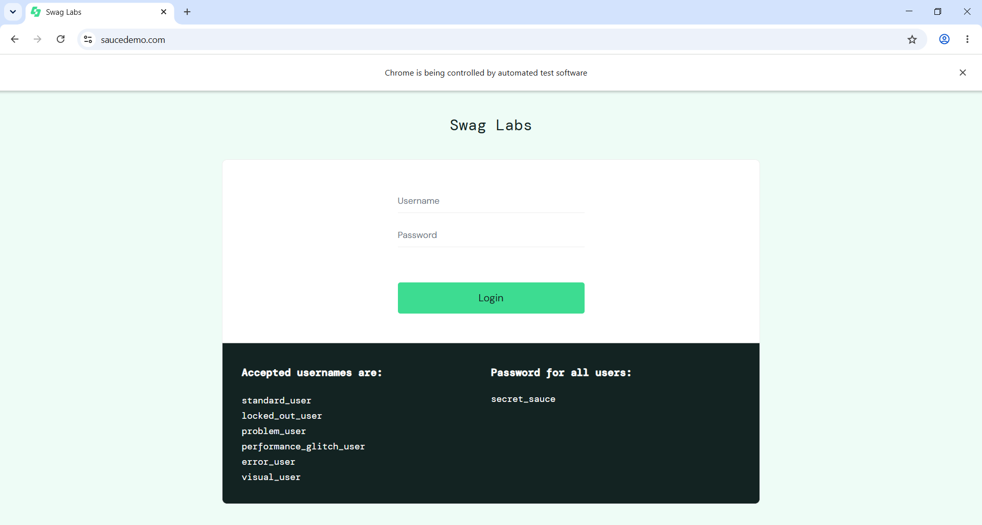
Figure 1. SauceDemo login page before entering credentials.
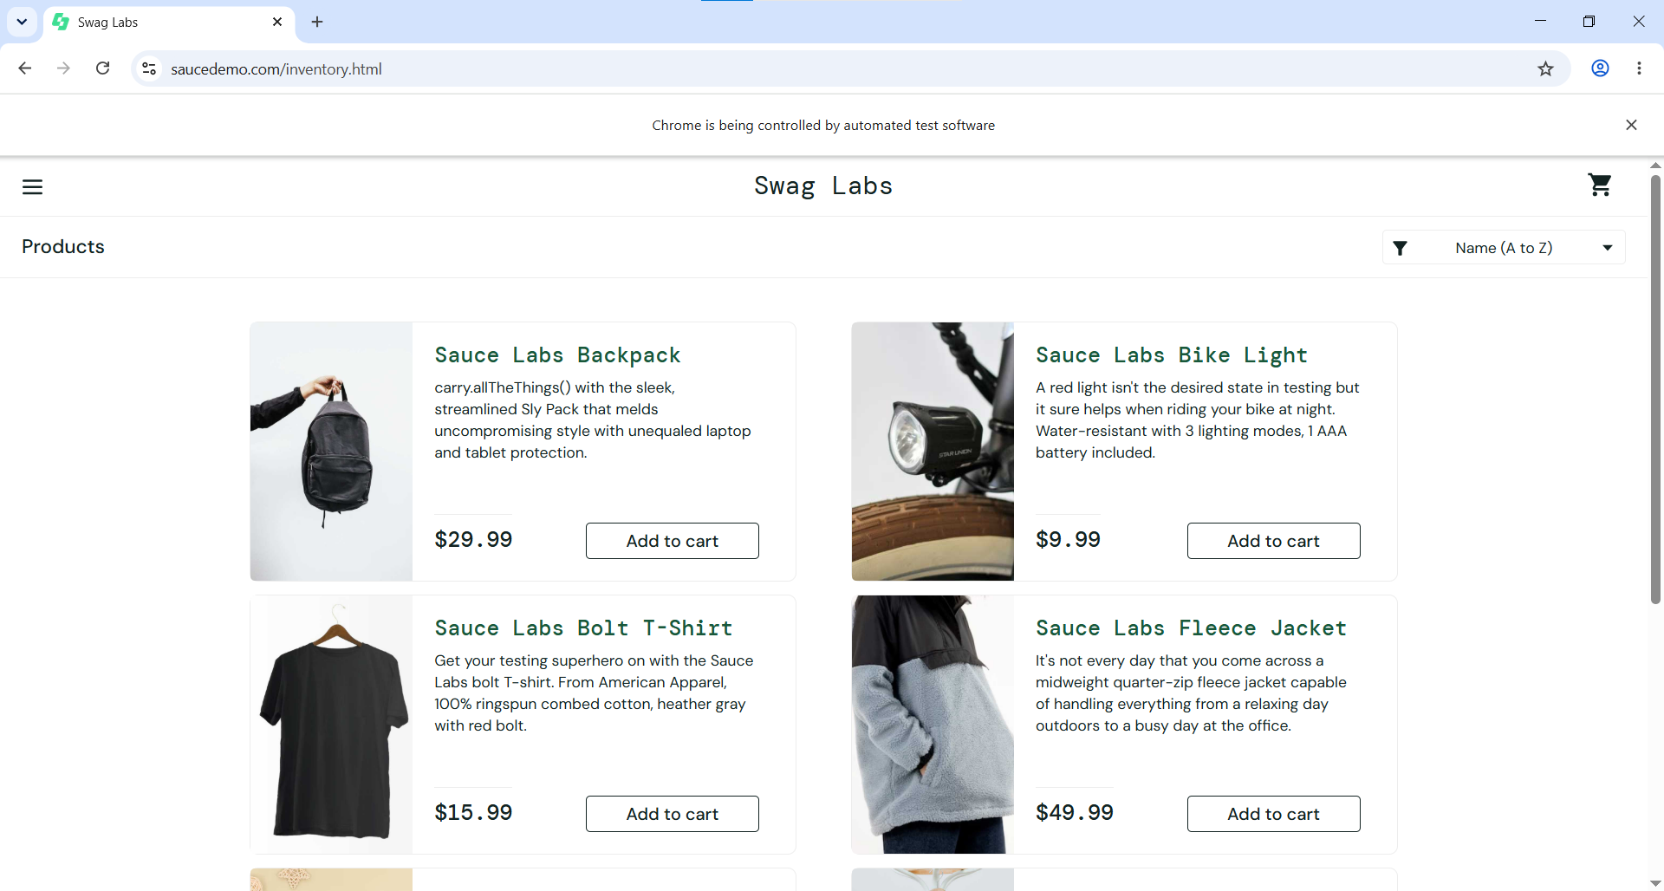
Figure 2. SauceDemo inventory page. A Chrome Password Manager warning is visible; this is a browser notification, not part of the application.

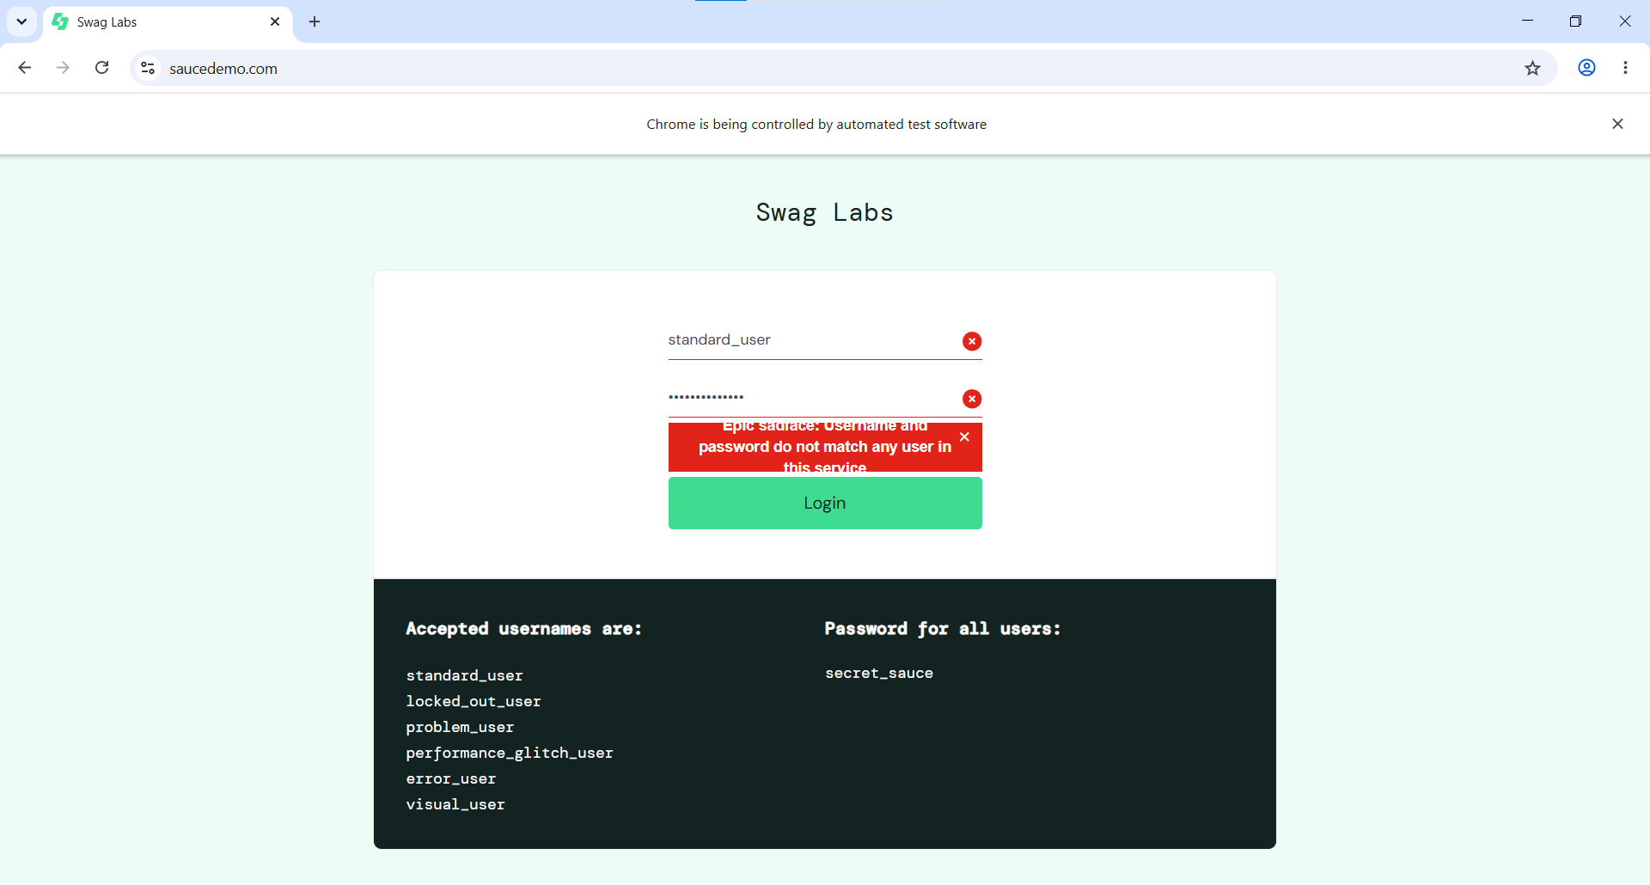
Figure 3. PyCharm source code and console output from a Selenium run.
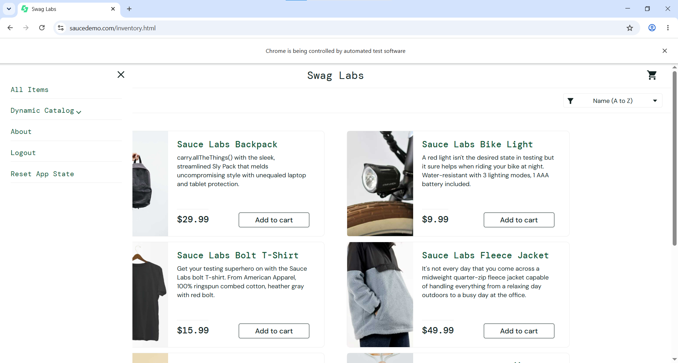
Figure 4. SauceDemo login page with invalid-credentials error displayed.

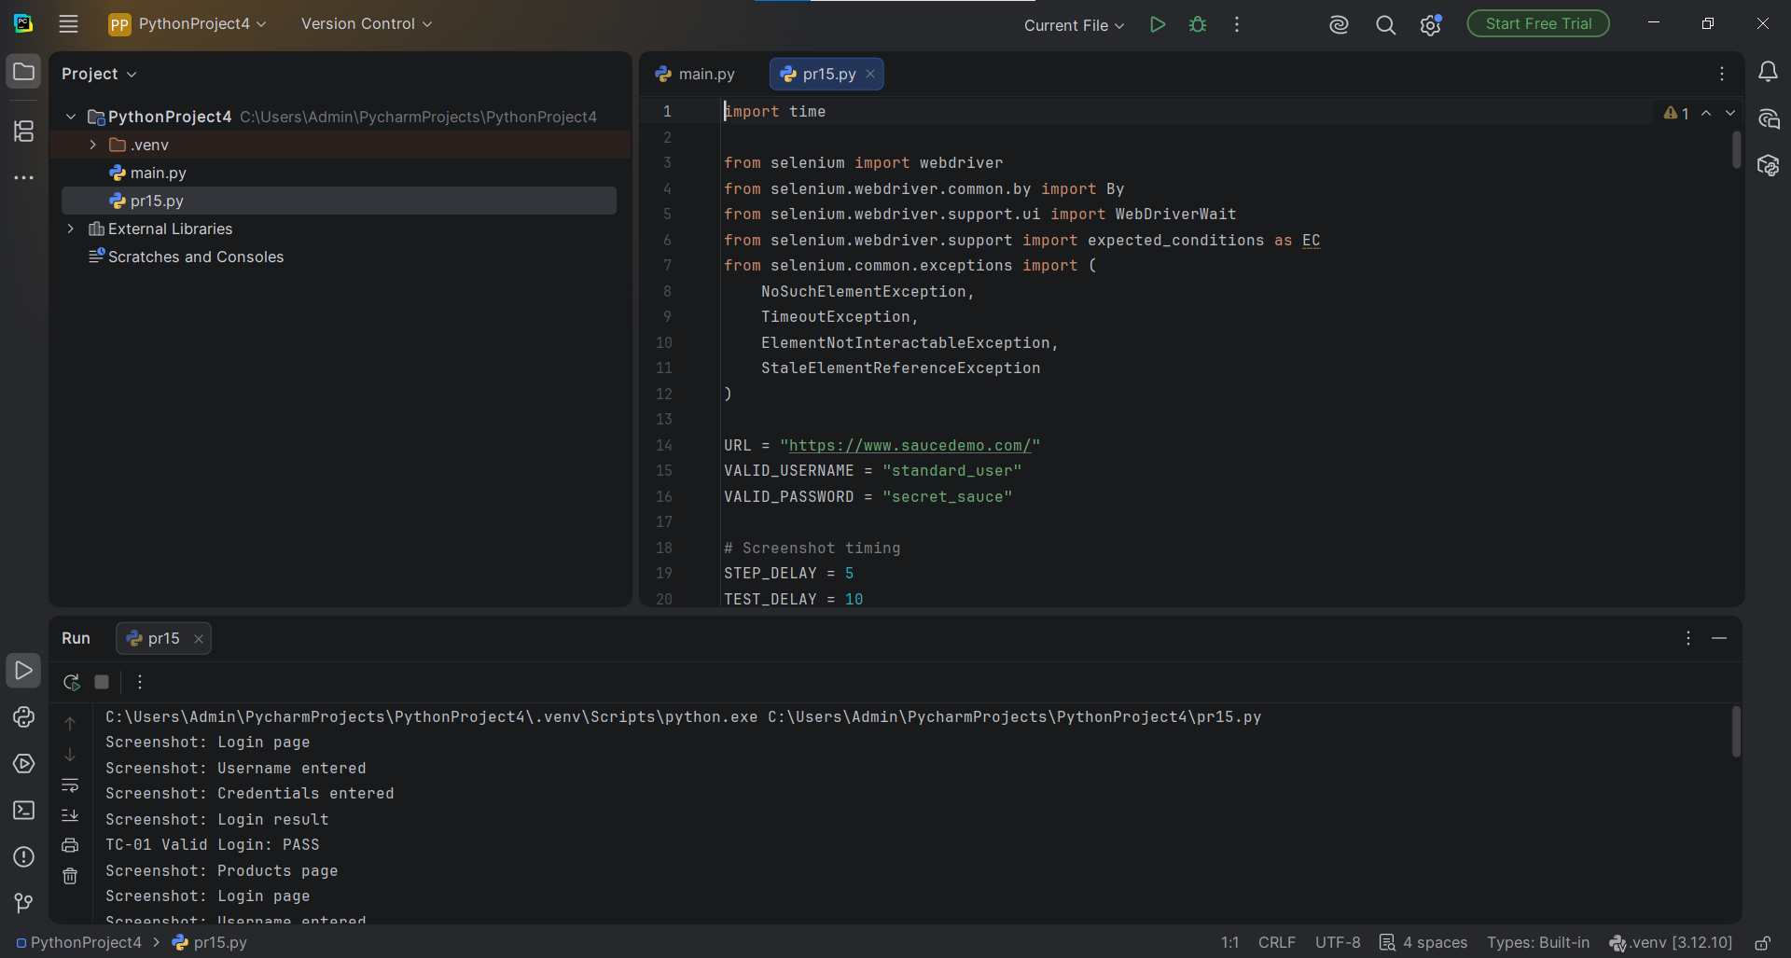
Figure 5. SauceDemo inventory page with the navigation menu open.
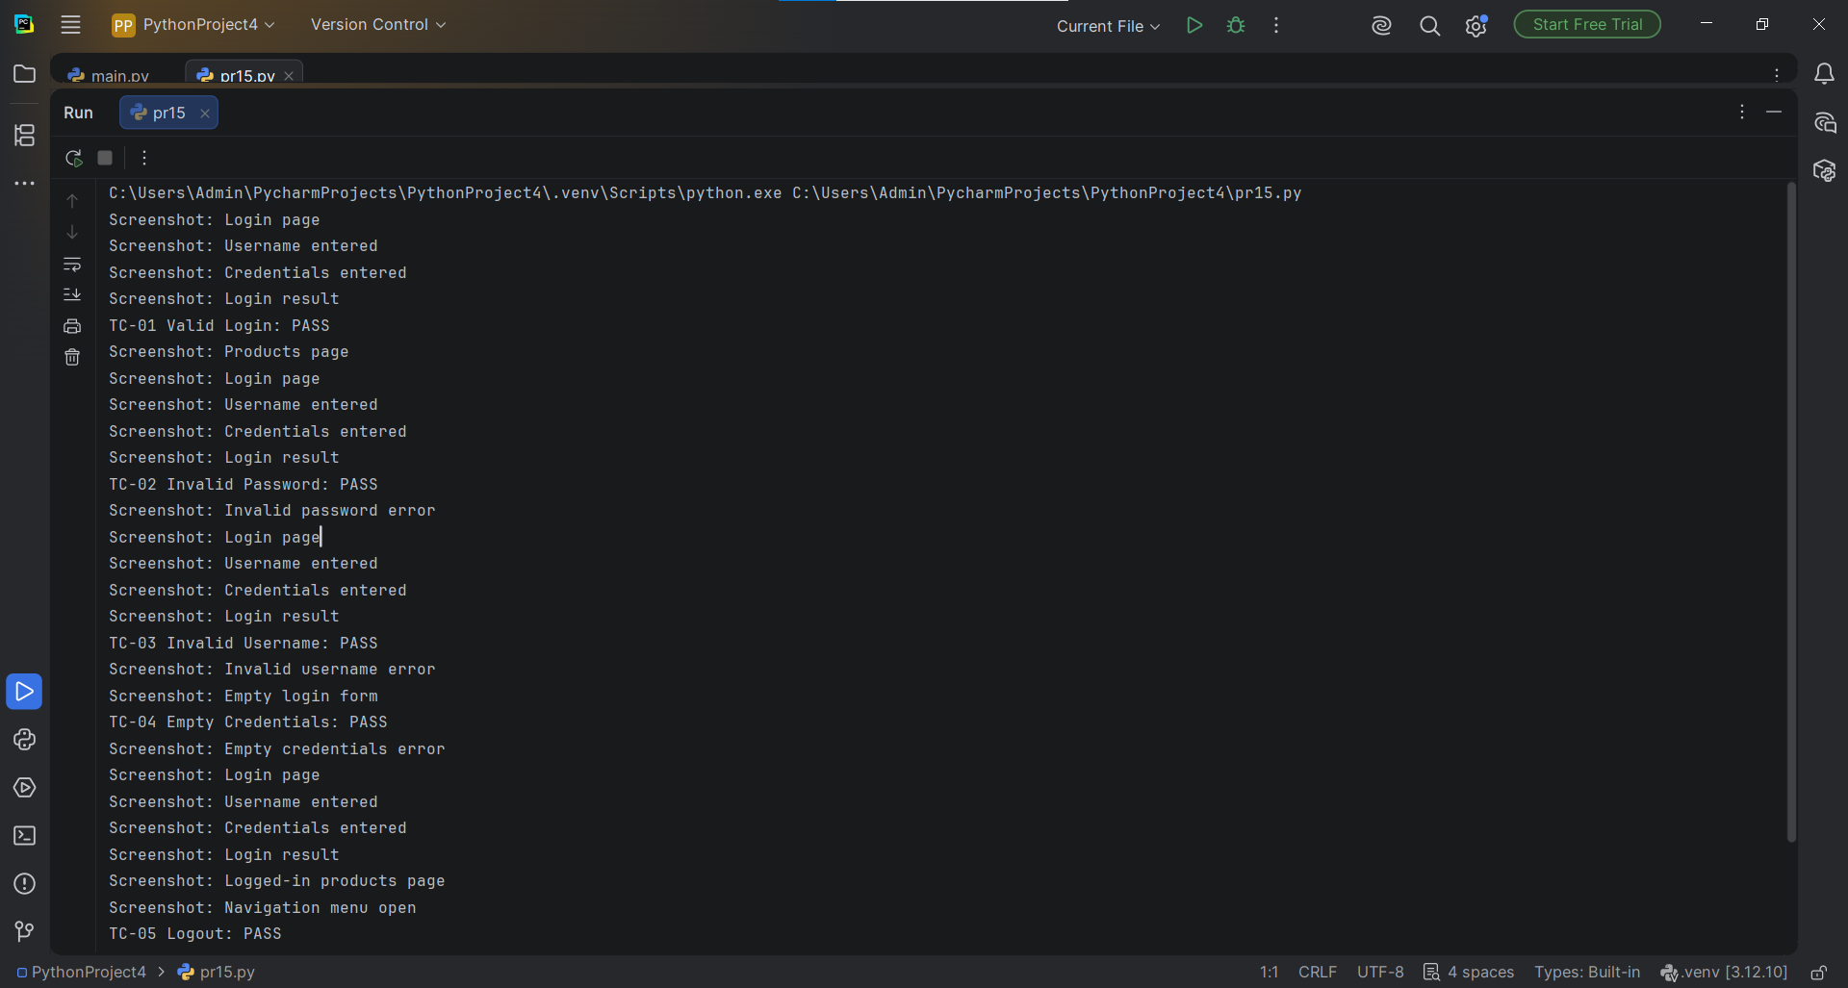
Figure 6. PyCharm console output showing the login test cases and logout test result.

13. Result
The provided execution evidence supports that the SauceDemo login and inventory workflow was automated with Selenium WebDriver. The visible PyCharm console output reports the five required scenarios as PASS. The report records these outcomes based on the supplied screenshots; the student should retain the complete console output from a fresh local execution for final verification.

14. Conclusion
This practical demonstrates how Selenium WebDriver can automate login testing for a web application. It covers positive and negative authentication scenarios, input validation, assertions, exception handling, and logout. Explicit waits help synchronize the automation with browser elements, while assertions compare actual application behavior with expected results. The screenshots provide supporting evidence of the login page, inventory page, error state, navigation menu, and test console.

15. Questionnaire
Q1. What is authentication testing?
Answer: Authentication testing verifies that valid users are allowed to access an application and invalid users are rejected.
Q2. What is Selenium WebDriver?
Answer: Selenium WebDriver is an automation API used to control web browsers and interact with web elements.
Q3. What is an assertion?
Answer: An assertion compares an expected condition with the actual result and indicates whether the condition is satisfied. Example: assert 'inventory' in driver.current_url.
Q4. What is exception handling?
Answer: Exception handling catches and manages runtime errors so the program can report problems instead of stopping unexpectedly.
Q5. Which exception can occur when an element cannot be found?
Answer: NoSuchElementException.

16. Final Checklist
☐ Create and run tutorial15.py in PyCharm.
☐ Verify all five scenarios execute as expected.
☐ Check that the final console output shows the actual status of each test.
☐ Include screenshots of the login page, successful login, invalid password, invalid username, empty credentials, logout, source code, and console output.
☐ Fill in the enrollment number on the cover page before submission.

